Lesson Notes: K-Means Clustering

Lesson Introduction
Today, we will learn K-Means Clustering, a fundamental unsupervised machine learning technique. Clustering allows us to group similar data points without pre-existing labels.
Mini Agenda:
- Introduction to Clustering
- What is K-Means Clustering
- K-Means Algorithm & How it Works
- Choosing the Optimum K Value (Elbow Method)
- Various Distance Measures
- Practical Examples with Dataset
- Business Scenario & Case Study
- Practice Questions & Assignment

Real-World Hook
Imagine you run an e-commerce business and want to group customers based on shopping habits. You don’t know the categories beforehand. How do you find patterns in customer data to target personalized marketing campaigns?
Problem: You have hundreds of customer records with different attributes. Manually finding groups is impossible.
Solution: K-Means Clustering automatically finds similar groups in the data.

Introduce Topic as a Solution
K-Means Clustering is a data grouping technique that divides your dataset into K clusters based on similarity.
- Each cluster contains data points that are closer to the cluster’s centroid than any other cluster.
- Widely used in customer segmentation, image compression, anomaly detection, and market analysis.

Theory Explanation

What is K-Means Clustering?
K-Means is an unsupervised learning algorithm that partitions data into K clusters. Each point is assigned to the cluster with the nearest mean (centroid).

Why Use K-Means?
- Simple and easy to implement
- Efficient for large datasets
- Helps discover hidden patterns

When to Use K-Means?
- When you don’t have labeled data
- When you want to group similar items
- For quick and scalable clustering

When NOT to Use
- Non-globular clusters or varying cluster sizes
- Datasets with many outliers
- High-dimensional sparse data

Advantages
- Simple and fast
- Scales to large datasets
- Easy to interpret

Disadvantages
- Requires predefined K
- Sensitive to outliers
- May converge to local minima

Limitations & Overcoming Them
- Limitation: Choosing K can be tricky → Use Elbow Method or Silhouette Score
- Limitation: Sensitive to outliers → Preprocess data, remove outliers

Alternatives
- Hierarchical Clustering
- DBSCAN
- Gaussian Mixture Models

How K-Means Works (Step-by-Step Algorithm)
- Choose K clusters
- Randomly initialize centroids
- Assign each data point to the nearest centroid
- Recalculate centroids as the mean of assigned points
- Repeat steps 3–4 until convergence
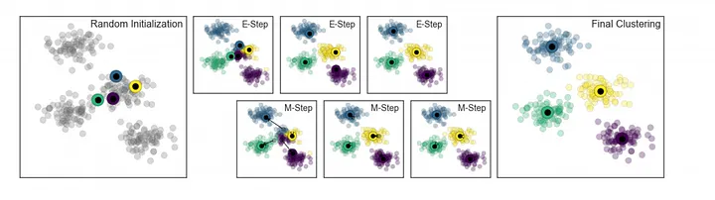
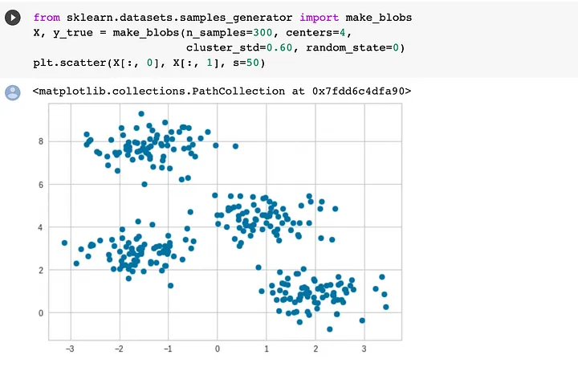
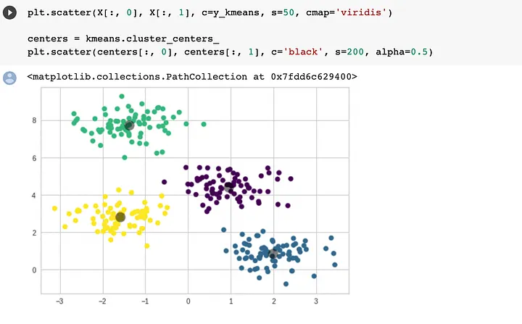

Key Characteristics
- Iterative refinement
- Distance-based assignment
- Minimizes Within-Cluster Sum of Squares (WCSS)

Mathematical Intuition
Minimize the following objective:
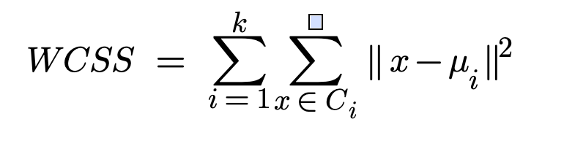
Where CiC_i is cluster i and μi\mu_i is centroid i.

Various Distance Measures
- Euclidean Distance (default)
- Manhattan Distance
- Minkowski (
- Cosine Similarity (angle)

https://www.analyticsvidhya.com/blog/2019/08/comprehensive-guide-k-means-clustering/
https://medium.com/analytics-vidhya/intuition-behind-k-means-clustering-f1ef6006479
https://www.geeksforgeeks.org/machine-learning/k-means-clustering-introduction/
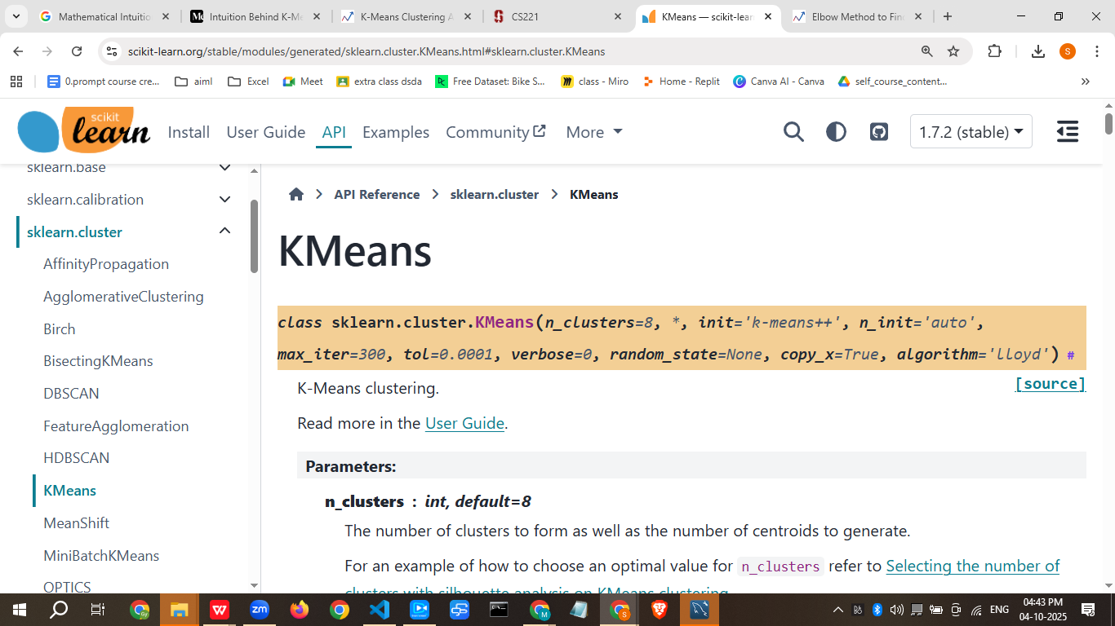
WHO we Decide best K- Value

What is the Elbow Method ?
The Elbow Method is a technique used in data analysis and machine learning for determining the optimal number of clusters in a dataset. It involves plotting the variance explained by different numbers of clusters and identifying the “elbow” point, where the rate of variance decreases sharply levels off, suggesting an appropriate cluster count for analysis or model training.
This method is a visual technique used to determine the best K value for a k-means clustering algorithm.
The elbow method is a heuristic technique for finding the optimal number of clusters in a dataset for K-means clustering. It involves calculating the Within-Cluster Sum of Squares (WCSS) (also known as inertia) for different numbers of clusters, plotting these values against the number of clusters, and identifying the "elbow point"—the point on the curve where the rate of decrease in WCSS begins to diminish significantly. This elbow point suggests the optimal number of clusters, as adding more clusters beyond this point yields diminishing returns in explaining the data's variance.
How it Works
- Calculate WCSS for different K values: The process involves running K-means clustering for a range of possible cluster numbers (K).
- Measure WCSS: For each K, the Within-Cluster Sum of Squares (WCSS) is calculated. WCSS is the sum of the squared distances of each data point to its assigned cluster's centroid.
- Plot the results: A curve is plotted with the number of clusters (K) on the x-axis and the WCSS on the y-axis.
- Identify the elbow point: The curve will typically show a steep decrease in WCSS as K increases, but at a certain point, the curve flattens out. This bending point, where the rate of decrease sharply changes, is the "elbow".
- Determine the optimal K: The K value at this elbow point is considered the optimal number of clusters.
Why it's Called the "Elbow" Method
The method is named for the visual resemblance of the plot to an elbow. The initial steep slope of the curve represents the significant reduction in error when adding more clusters, while the flattened section after the elbow signifies that the reduction in error becomes much smaller with each additional cluster.
Limitations
- Subjectivity:
- The "elbow" can sometimes be ambiguous, leading to subjective interpretation of the optimal number of clusters.
- Data-dependent:
- The method works best when there is a clear, discernible elbow in the curve. If the data is not well-clustered, the curve might be smooth, making it hard to find a distinct elbow point.
https://www.geeksforgeeks.org/machine-learning/elbow-method-for-optimal-value-of-k-in-kmeans/

silhouette score
The silhouette score is a metric for evaluating the quality of clusters in a dataset, measuring how well each data point fits into its own cluster (cohesion) compared to other clusters (separation). It ranges from -1 to +1, where a score near +1 indicates good clustering, with points far from neighboring clusters, while a score near 0 suggests overlapping clusters, and negative scores suggest points may be in the wrong cluster. This metric is particularly useful for determining the optimal number of clusters in algorithms like K-Means, often by finding the number of clusters that maximizes the average silhouette score.
How it works:
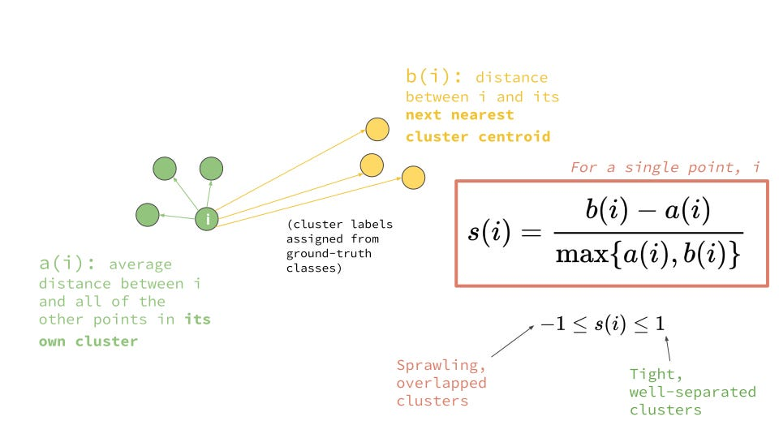
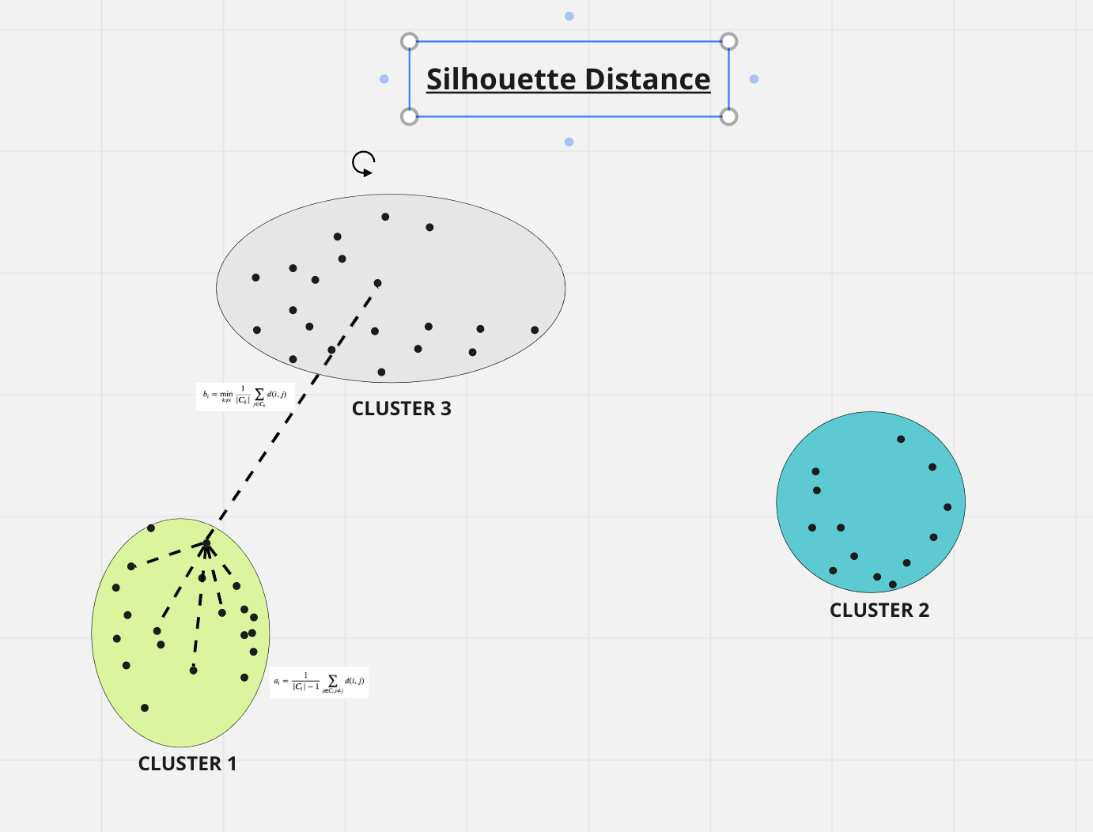
For each data point, the silhouette score quantifies two main factors:
- Cohesion (a(i)): The average distance from the data point to all other points in the same cluster. A smaller distance means the point is tightly bound to its cluster.
- Separation (b(i)): The average distance from the data point to all points in the nearest neighboring cluster. A larger distance indicates good separation from other clusters.
The score for a single point i is then calculated as s(i) = (b(i) - a(i)) / max(a(i), b(i)).
Interpreting the score:
- Near +1:
- The point is well-matched to its own cluster and far from other clusters, indicating good clustering.
- Around 0:
- The point is close to the boundary between two neighboring clusters and is poorly separated.
- Negative values:
- The point is likely assigned to the wrong cluster, as it is closer to a neighboring cluster than its own.
How it's used:
- Determining the optimal number of clusters (k):
- The silhouette score can be calculated for various numbers of clusters (k). The value of k that yields the highest average silhouette score across all data points is often considered the optimal number of clusters.
- Validating cluster quality:
- It provides an overall measure of how good the entire clustering solution is.
- Identifying outliers:
- Points with very low or negative silhouette scores can be identified as potential outliers or misclassifications.

https://www.geeksforgeeks.org/machine-learning/what-is-silhouette-score/
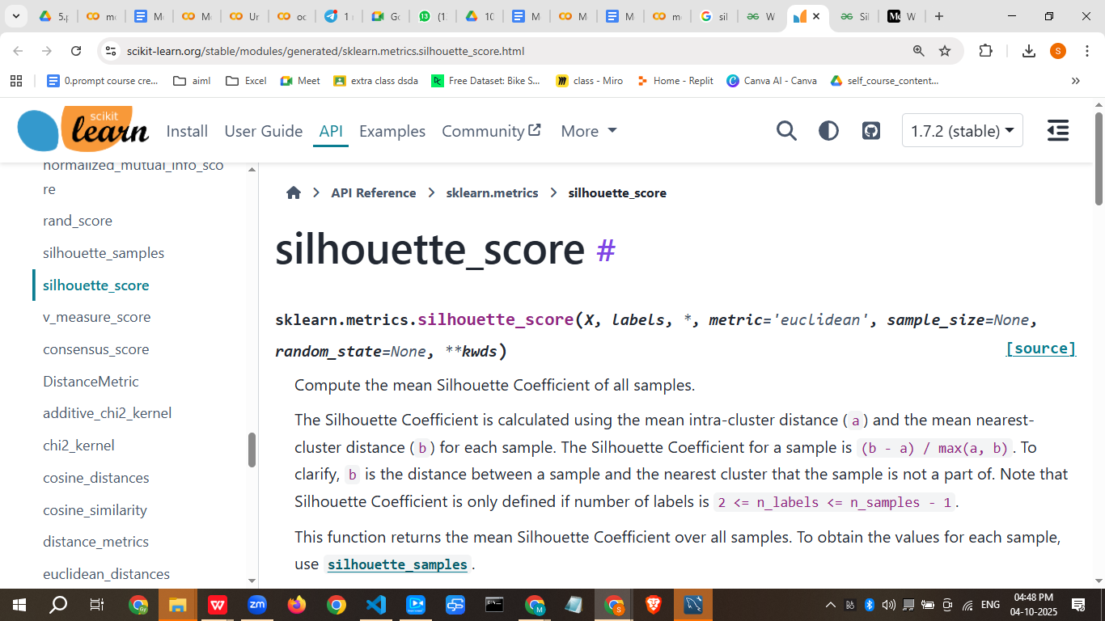

Practical Example (Dataset + Exercises)
Sample Dataset (50 points):
Age | Annual Income | Spending Score
25 | 50000 | 60
45 | 80000 | 20
35 | 60000 | 40
... | ... | ...
Python Implementation:
- import pandas as pd
- from sklearn.cluster import KMeans
- from sklearn.preprocessing import StandardScaler
- import matplotlib.pyplot as plt

- # Sample dataset
- data = pd.DataFrame({
- 'Age': [25,45,35,50,23,40,30,60,28,55]*5,
- 'Income': [50000,80000,60000,90000,48000,75000,55000,95000,52000,88000]*5,
- 'Score':[60,20,40,10,70,30,50,15,65,25]*5
- })

- # Scaling
- scaler = StandardScaler()
- X_scaled = scaler.fit_transform(data)

- # KMeans Clustering
- kmeans = KMeans(n_clusters=3, random_state=42)
- data['Cluster'] = kmeans.fit_predict(X_scaled)

- # Visualize 2D clusters (Age vs Score)
- plt.scatter(data['Age'], data['Score'], c=data['Cluster'], cmap='rainbow')
- plt.xlabel("Age")
- plt.ylabel("Spending Score")
- plt.title("K-Means Clusters")
- plt.show()

Business Scenario
Company: Retail Chain
Problem: Target marketing campaigns
Solution: Use K-Means to segment customers into high spenders, medium spenders, and low spenders to send personalized offers, improving conversion rate and sales.

Practice Session (5–10 Questions)
- What type of learning is K-Means?
- Explain what a centroid is.
- Describe the Elbow Method.
- Name three distance measures used in K-Means.
- Write Python code to cluster the following data: Age = [22,28,35,40], Income = [20000,25000,50000,60000]
- When should you NOT use K-Means?
- How does K-Means assign points to clusters?
- What is WCSS?
- Give one real-world application of K-Means.
- Explain the difference between Euclidean and Manhattan distance.

Case Study
Mini Project: Customer Segmentation for E-Commerce
- Dataset: 200 customers with Age, Income, Spending Score
- Apply K-Means with K=3
- Visualize clusters
- Create marketing strategy for each cluster
- Evaluate results using WCSS and Silhouette Score

Assignments
- Load the Mall Customers dataset. Perform K-Means clustering and find the optimal K using Elbow Method.
- Visualize clusters using Age vs Annual Income.
- Analyze each cluster and suggest marketing actions.
- Experiment with different distance measures and report differences.

Quiz (3–5 Questions)
- What is the purpose of K-Means Clustering?
- How do you choose the number of clusters?
- Name one limitation of K-Means.
- Which Python library is used for K-Means?
- Explain the role of a centroid.

Recap of Today’s Lesson
- Clustering groups similar data points
- K-Means is a popular unsupervised algorithm
- Choose K carefully using Elbow Method
- Distance measures affect clustering
- Practical applications in business, marketing, and finance

Streamlit User Interface
This lesson can be practically applied in a Streamlit app to upload datasets, select features, choose K, and visualize clusters interactively.
Resource Links:
- Scikit-learn KMeans Documentation
- Elbow Method Explanation
- Clustering Tutorial by Towards Data Science

Common Interview Questions
- Explain K-Means Clustering in simple words.
- How do you choose the number of clusters?
- What is the difference between K-Means and Hierarchical Clustering?
- How does scaling affect K-Means?
- What distance metrics can K-Means use?
- What are the advantages and disadvantages of K-Means?
- How to handle outliers in K-Means?
- Explain the Elbow Method.
- How do you interpret clusters in business scenarios?
- Write Python code for a basic K-Means clustering example.

I can now create a fully interactive Streamlit app for this lesson where learners can upload data, select K, visualize clusters, and experiment with distance measures—turning this lesson into a hands-on project.

If you want, I can also create a visual Streamlit app version of this lesson with interactive K-Means demo, so students can see clusters change in real-time.
Let’s create a complete Streamlit app for K-Means Clustering where users can upload a dataset, select features, choose K, and see clusters visually. Here’s the full code:
# kmeans_streamlit_app.py
import streamlit as st
import pandas as pd
import matplotlib.pyplot as plt
from sklearn.cluster import KMeans
from sklearn.preprocessing import StandardScaler

# ---- App Title ----
st.title("📊 K-Means Clustering Interactive App")
st.markdown("""
This app allows you to perform **K-Means Clustering** on your dataset.
Upload a CSV file, select features, choose the number of clusters (K), and visualize clusters.
""")

# ---- File Upload ----
st.sidebar.header("Upload Your CSV")
uploaded_file = st.sidebar.file_uploader("Upload CSV", type=["csv"])

if uploaded_file:
df = pd.read_csv(uploaded_file)
st.subheader("Data Preview")
st.dataframe(df.head())

# ---- Feature Selection ----
numeric_columns = df.select_dtypes(include=['int64','float64']).columns.tolist()
st.sidebar.header("Select Features for Clustering")
selected_features = st.sidebar.multiselect("Features", numeric_columns, default=numeric_columns[:2])

if len(selected_features) >= 2:
X = df[selected_features]

# ---- Scaling ----
scaler = StandardScaler()
X_scaled = scaler.fit_transform(X)

# ---- Choose K ----
st.sidebar.header("K-Means Parameters")
k = st.sidebar.slider("Select Number of Clusters (K)", 1, 10, 3)

# ---- K-Means Clustering ----
kmeans = KMeans(n_clusters=k, random_state=42)
clusters = kmeans.fit_predict(X_scaled)
df['Cluster'] = clusters

# ---- Display Results ----
st.subheader("Clustered Data")
st.dataframe(df.head())

# ---- Cluster Visualization ----
if len(selected_features) == 2:
st.subheader("Cluster Visualization (2D)")
plt.figure(figsize=(8,6))
for cluster in range(k):
plt.scatter(
df[df['Cluster']==cluster][selected_features[0]],
df[df['Cluster']==cluster][selected_features[1]],
label=f'Cluster {cluster}'
)
plt.xlabel(selected_features[0])
plt.ylabel(selected_features[1])
plt.title("K-Means Clusters")
plt.legend()
st.pyplot(plt)
else:
st.info("Select exactly 2 features for 2D visualization.")

# ---- Elbow Method Visualization ----
st.subheader("Elbow Method to Find Optimal K")
wcss = []
for i in range(1,11):
km = KMeans(n_clusters=i, random_state=42)
km.fit(X_scaled)
wcss.append(km.inertia_)
plt.figure(figsize=(8,5))
plt.plot(range(1,11), wcss, marker='o')
plt.xlabel("Number of Clusters (K)")
plt.ylabel("WCSS")
plt.title("Elbow Method")
st.pyplot(plt)

else:
st.warning("Please select at least 2 numeric features for clustering.")

else:
st.info("Upload a CSV file to get started.")

st.markdown("---")
st.markdown("Made with ❤️ by OpenAI GPT-5 Mini")

How this App Works:
- Upload CSV file (any dataset with numeric columns).
- Select features for clustering.
- Choose K (number of clusters) using the slider.
- View clustered data with an additional Cluster column.
- Visualize clusters in 2D (if 2 features are selected).
- Elbow Method plot helps choose the optimal K.

✅ Next Step:
You can run it locally with:
pip install streamlit pandas scikit-learn matplotlib
streamlit run kmeans_streamlit_app.py

If you want, I can enhance it further to support interactive 3D plotting for 3 features and allow different distance measures for K-Means, making it even more like a full teaching tool.

